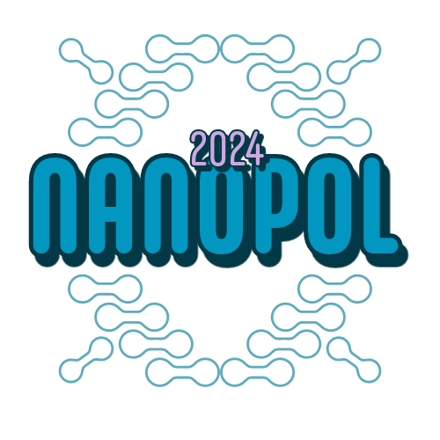
University of Banja Luka
Faculty of Natural Sciences and Mathematics

„Nanomaterials and Polymers – Applied Chemistry for Sustainable Development“
NanoPol 2024 Conference

Preliminary programme

DAY 1 (June 13, 2024)

8.30-9.00 Registration and media statements
9.00-9.15 Greetings by host institution and opening
Nanomaterial section
9.15-9.45 (25+5 minutes)
Prof dr Matteo GUIDOTI, Subject: Nanosystems (risks and opportunities)
9.45-10.15 (25+5 minutes)
Prof dr Dragana TOMAŠEVIĆ PILIPOVIĆ, Subject: Nanomaterials and environment
10.15-10.45 (25+5 minutes)
Prof dr Radovan KUKOBAT, Subject: Metalic organic frameworks
10.45-11.30 Coffee/cookie break with poster session
Nanomaterial section
11.30-12.00 (25+5 minutes)
Dr Eyad KHALAF, Subject: natural fibers/rubber composites
12.00-12.30 (25+5 minutes)
Prof dr Anita GROZDANOVA, Subject: Eco-friendly polymer composites
12.30-13.00 (25+5 minutes)
Prof dr Miroslav HUSKIĆ, Subject: New, 5-HMF based polymers
13.00 Greetings and closing of the presentation part
13.00-15.00 buffet networking lunch, poster observation and evaluation, stand visits (on site)
14.30 Announcement of the best poster, memorial pictures and prize delivery

DAY 2 (June 14, 2024)

8.00-8.15 Gathering at the parking lot of the Faculty of Natural Sciences (Mladena Stojanovića 2, Banja Luka) limited number of participants
8.15-13.00 travel and visit to the industry, discussion with the enginners
13.00-14.00 short visit to the historical/natural atraction in teh viccinity of the industrial site (snacks and drinks available)
14.00-16.00 Farewell lunch in the rural restaurant
17.00 arrival at the parking lot of the Faculty of Natural Sciences (Mladena Stojanovića 2, Banja Luka)

